FOOD STATIONS WORKSHEET

Station 1: What’s in the Box?

Box 1: _____________________ Box 2: _____________________

Box 3: _____________________ Box 4: _____________________

Box 5: _____________________

Station 2: Unscramble

__ __ __ __ __ __ __ __ __ __ __ __ __ __ __ __

Station 3: Make matches

Station 4: Put the words into the correct category

Meats | Fruits | Vegetables | Dairy
1. | 1. | 1. | 1.
2. | 2. | 2. | 2.
3. | 3. | 3. | 3.

Station5: Read and/or spell with your teacher.

Station 6: Silent reading on your own

Station Signs: Pictures taken from Microsoft Clip Art

Station 1:

What food is it?

Station 2:

MATCHING!

Station 3:

Unscramble the Letters

Station 4:

Categorize the food

Station 5:

Sight Words

Station 6:

Silent Reading Corner

Unscramble
A | A | C | D
D | G | H | I
N | O | O | P
T | Y | Z | Z

Matching: pictures taken from http://openclipart.org/

BREAD | 
CHERRIES | 
BROCCOLI | 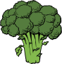
ORANGE | 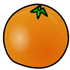
HAMBURGER | 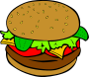
EGGS | 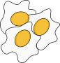

Categorize

CHICKEN | HAM
CHEESE | MILK
WATERMELON | GRAPES
CELERY | LETTUCE
PINEAPPLE | FISH
CABBAGE | CREAM

